- Introduction
- Purpose of document
This document contains the specification and design of the Open Source GNSS Reference Server component
The design details of this component are presented using text narrative, class diagrams, class descriptions, object diagrams and sequence diagrams. The design overview and detailed design chapters capture points of interest to future maintainers of this component.
- Context
The OSGRS provides data for Assisted-GNSS applications, an overview is shown in figure 1.The OSGRS is configurable to connect to one or more sources of GNSS data, for example a specific GNSS receiver or an internet based GNSS data server. It caches the data and then provides it on request to the A-GNSS client. It accepts connections via HTTP and uses the GRIP protocol defined in the GRIP Document.
- Overview

- Definitions
Data Source
A Data Source is a source of GNSS data, e.g. NovAtel OEM4
Servlet
A servlet is a small Java program that runs within a Web server. It allows a developer to add dynamic content to a web server for the Java platform
Servlet Container
Specialized web server designed to hold and execute servlets. They are also know as web containers and web engines.
Reference time
This is a GNSS assistance data type that contains a single reference time and TOW assist data for each satellite. The TOW assist data contains the Telemetry word (TLM) and the Handover word (HOW) that are broadcast by each satellite.
PRN
Pseudorandom noise code that uniquely identifies each satellite in GPS.
Navigation model
The navigation model includes the parameters that model the orbit and clock state of a satellite.
Ionosphere model
The ionosphere model contains information needed to model the propagation delays of the GNSS signals through the ionosphere.
Almanac
The almanac specifies the coarse, long term model of the satellite position and clocks.
UTC model
The UTC model contains a set of parameters needed to relate GNSS time to Universal Time Co-ordinate (UTC).
Acquisition Assistance
The acquisition assistance data contains parameters that enable fast acquisition of the GNSS signals in the handset.

- Acronyms

A-GNSS Assisted GNSS
DGNSS Differential GNSS
GPS Global Positioning System
GNSS Global Navigation Satellite Systems
GRIP GNSS Reference Interface Protocol
ICD Interface Control Document
OSGRS Open Source GNSS Reference Server
PRN Pseudorandom Noise Codes
RTCM Radio Technical Commissions for Maritime Services
RTI Real Time Integrity
TCP Transmission Control Protocol
TOW Time of Week
UTC Universal Time Coordinate

- References
- ICD-200 http://www.navcen.uscg.gov/pubs/gps/icd200/
- Galilleo Open Space Interface Control Document http://www.galileoju.com/
- GRIP Document
- Radio Technical Commissions for Maritime Services http://www.rtcm.org
- Role and responsibilities
- Role
The Open Source GNSS Reference Server is a component that is used to provide assistance data to a A-GNSS client, it gathers data from various configurable data sources.
The OSGRS will provide all of the data types requested and appropriate errors for unavailable data. The server provides data which will be specific to the GNSS ICDs per satellite. For example the GPS data is specified in the ICD-200 http://www.navcen.uscg.gov/pubs/gps/icd200/ and Galileo data is specified in the Galilleo Open Space Interface Control Document ht. However, there are exceptions for DGNSS, RTI and reference time model data formats; these are defined in the GRIP interface document.
- Requirements
The Open Source GNSS Reference Server component must support the following:
- Support HTTP 1.1 (POST)
- Open source
- Provide a NovAtel plug-in module.
- Ability to archive assistance data
- Use the GRIP to provide assistance data
- Log system events
- Pluggable architecture so that data source can be replaced
- Ability to configure behavior through configuration file
- Data Source requirements
This section has requirements specific to different data sources:
- At present we only have one Data Source type implemented; i.e NovAtel OEM4(s).
- NovAtel
- Support NovAtel OEM4
- Support up to 4 receivers
- Connect to each receiver with an IP address and port number

- Responsibilities
The Open Source GNSS Reference Server component has the following responsibilities:
- Listen for connection requests
- Logging
- Implement GRIP.
- Exclusions and limitations
The data archiver component is presently not implemented. Refer to the GRIP document section 5 for limitations and formats of specific data types.
The logging of system events is not complete and overlaps with debugging information.
DGNSS and acquisition assistance have not been implemented.
The real time integrity generated in OSGRS uses the SV health information in the satellite ephemeris. This information can be several hours old.
- Detailed context
The OSGRS component interacts with the following components (arrows show the direction of the dependencies), as shown in figure 1.

- A-GNSS data collector collaborator
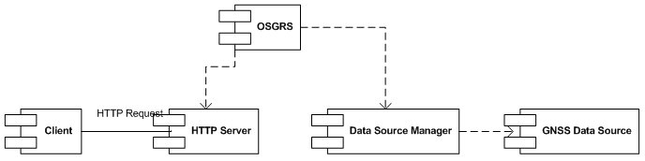

Client
The client component represents an external entity, the client makes a
connection and requests GNSS assistance data\

GNSS Data Source
This component provides GNSS Assistance data. This may be a GNSS
receiver or an internet data source.
- Refer to Data Source requirements for more information.
- Environment
The OGSRS component has been developed on the Java 2 Platform Standard Edition 5.0 (J2SE2 5.0) running on Microsoft Windows XP.
- Licensing
GNU Public License Version 2

- Key scenarios
- Actors
This section describes the actors involved in the key scenarios for this component.
- Primary actors
- Client
Queries for assistance data
- User
Starts up the OSGRS

- Secondary actors
- File System
Stores the log and config files.
- Config Manager
Load and update config information.
- GNSS Receiver
Provides GNSS information including ephemeris, ionosphere, UTC model and pseudo range measurements.
- Data Source
Retrieves GNSS data from a GNSS receiver and provides it to the data cache.
- HTTP Server
Handles HTTP connections. Initializes and launches main servlet to process client requests.
- Data Source Manager
Collects and provides A-GNSS data to the OSGRS.
- Scenario descriptions
This section contains OSGRS scenarios, section Pluggable Data Sources scenarios contains scenarios for each
pluggable data source
- OSGRS
- The OSGRS starts up
This scenario is invoked by the user.

Primary actor
The user
Secondary actors -
- Data Source
- Data Receiver
- GNSS Receiver
- HTTP Server
- ConfigManager

Precondition
- none

Description

1 The user starts up the OSGRS.
2 The Server configurations are loaded by the ConfigManager
3 Data Source Manager is started.
4 The Data Receiver connects to Data Source(s) depending on configuration.
5 The Data Receiver retrieves data from the Data Source(s), see scenario The OSGRS retrieves GNSS data
6 The HTTP Server opens the listener port to allow client connections.

Alternative outcomes

From 2 Server configurations are unable to be loaded, a message is logged to standard out, OSGRS shuts down.
From 4 Unable to connect to data source(s), a message is logged to standard out.
From 6 The OSGRS fails to start up because configured port is in use; a message is logged to standard out and the OSGRS is shutdown.

- The OSGRS retrieves GNSS data
This scenario is invoked by the Data Source Manager.

Trigger - Start-up / data refresh interval / data retrieval forced

Secondary actors -
- File System
- GNSS Receiver
- Data Receiver
Preconditions
- Scenario The OSGRS starts up successfully completed
- Connection to Data Source established.
Description

1 The Data Receiver retrieves all required data types from the data source
2 Cache the data along with timestamp

Alternative outcomes

From 1 The GNSS data is unavailable and the OSGRS will continue to poll for data at the configured interval.

- A client connects to the OSGRS

This scenario is invoked by the Client

Primary actor - The Client

Secondary actor - HTTP Server

Precondition
- The OSGRS is up and running
- The listener socket is open
Description

1 A connection attempt is made by a client
2 T he OSGRS accepts the connection.

Alternative outcomes

None
- The OSGRS receives a request for A-GNSS data
This event is invoked by the Client.
Primary actor - The Client.
Secondary actors -
- Data Receiver
- Http Server
Precondition
- The client has a connection with the OSGRS
Description
1 The OSGRS receives a request for a list of A-GNSS data using the GRIP.
2 Decode & verify request
3 The OSGRS packages the assistance data requested
4 The data server returns the assistance data to the client using the GRIP protocol.

Alternative outcomes

From 2 The client sends an invalid query not complying with GRIP protocol, the
OSGRS will return an error message to the client.
From 3 The assistance data requested is unavailable or unsupported, a response is given to the client using GRIP, and a message is logged to standard out.

- Expiring stale data
This event is invoked by the DataCache
Trigger - timer interval on process for checking data staleness.
Secondary actors - File System
Precondition
- OSGRS is running
Description
1 The system activity timer compares data staleness to configured settings
2 Log information about each stale data type to recorded in logs.
3 Remove stale data

Alternative outcomes
From 1 Data still within acceptable range for staleness. Data is not removed.
- Disconnection of a client
This event is invoked by either; the client or the jetty web container
Primary actors - The client or jetty web container.
Precondition
- Client is connected
Description
1 The connection is closed
Alternative outcomes
n/a
- Shutdown of OSGRS
Primary actor - The user

Precondition
- OSGRS is running

Description
1 Disconnect all clients, refer to Disconnection of a client
2 Close connection to GNSS data source(s)
3 Output to logs the time of shutdown
4 Close the OSGRS.

Alternative outcomes
none

- Pluggable Data Sources scenarios
- NovAtel Data Source
This section describes the NovAtel component of the OSGRS.
- Start up
This scenario is invoked by the Data Source Manager.
Trigger - OSGRS starts up - retrieves GNSS Data
Precondition
- OSGRS is running
Description
1 Establish connections to receivers
2 Setup the correct logging for receivers
Alternative outcomes
From 1 Unable to establish a connection to the receiver, a message is logged to logs, a timer is started and an attempt is made to retry the connection(s) once this timer expires.
- Connecting to NovAtel receivers
This scenario is invoked by the Data Source Manager
Trigger - OSGRS starts up / a connection to a receiver has been lost
Precondition
- OSGRS is running
Description
1 Check the status of each configured NovAtel connection.
2 Make a connection to the receiver if necessary.
Alternative outcomes
From 2 Unable to make a connection; a timer is started and an attempt is made to retry the connection(s) once this timer expires.
- Retrieving data
This scenario is invoked by the Data Source Manager. The idea here is to setup the correct logging on the NovAtel so that we do not need to manage timers within the OSGRS; thus we cache fresh data whenever they are updated on the NovAtel.
Trigger - The Data Source Manager timer expires / data becomes stale
Precondition
- Connections are established to NovAtel receiver(s).
Description
1 Make a request to NovAtel data sources
2 Collate all satellites
3 Calculate sats in view from specified lat and long.
4 Return data requested.
- Disconnection from a receiver
This scenario is invoked by the Data Source Manager
Trigger - Receiver connection lost
Precondition
- OSGRS is running.
- Connection to receiver has been lost
Description
1 Log message to logs
2 Retry the connection, refer to scenario Connecting to NovAtel receivers
- Shutdown
This scenario is invoked by the Data Source Manager or the OSGRS
Trigger - The OSGRS shuts down.
Description
1 Close connection to receiver.

Alternative outcomes
none

- Properties
- Sizing and capacity
- Support at least 10 concurrent client connections
- Support more then 1 NovAtel receiver
- Support more then 1 outstanding request (i.e. multiple connections from 1 client).
- Performance
There are no specific performance requirements.
- Standards compliance
The OSGRS must support the standards as defined in GRIP.
- Third party software dependencies
The OSGRS is dependant on the Java 2 Platform Standard Edition (J2SE) 5.0 (J2SE 5.0) , Jetty Web Server version 6.1.1 and the Xerces2 Java Parser 2.9.0.
- High Level Design
This chapter describes the high-level design of the Open Source GNSS Reference Server. UML diagrams are used to assist in the description of the design. Class diagrams usually show only a single concept at a time. Where classes from other components are used, those classes are highlighted in grey.
- Key decisions
- HTTP Server keeping connections
- Pluggable architecture - plug-in names are resolved from class name, at present only 1 plug-in class will be supported at any time.
- Data staleness- each data type has a unique expiry time period.
- Internal structure
The OSGRS component is contained within a single package as shown in Figure 3 - “OSGRS component - package structure”.
- OSGRS component - package structure
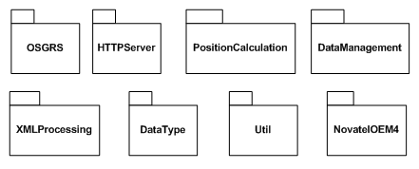
OSGRS.OSGRS
The main class of OSGRS. Contains the main function of the OSGRS.
OSGRS.NovatelOEM4
The NovAtel OEM4 plug in provided by the OSGRS.
OSGRS.XMLProcessing
The classes associated with xml processing. This includes request parsing, request handling and response generation.

OSGRS.PositionCalculation
The classes assoicated with calculating user and satellite position.
OSGRS.HTTPServer
The classes associated with the HTTP server aspect of OSGRS.
OSGRS.DataManagement
The classes responsible for the management of GNSS data.
OSGRS.Util
Utility classes such as the config manager and debug logger.
OSGRS.DataType
Contains the data models for each of the data handled by OSGRS.
- Component dependencies
The component does not use any internal packages.
- Debug messages

This component provides no debug console commands, debug messages are provided in a “.log” file corresponding to the class name, it is in a xml format provided by the java.util.logging component. Different levels of debugging can be configured, modify systemConfig.conf to control the debug output.
- Design notes
- Patterns used
None identified
- Issues
None identified
- Alternatives
None identified
- Process start-up
This component has the following initialisation requirements for start-up:
- Successful load of configurations files.
- initialise data sources
- initialise web server
- Threading model
The current design uses multi threading. Each data type in the data cache has its own ‘TimerTask’ thread which periodically. The NovAtel OEM 4 plug-in has an internal thread for reading output from the terminal server.
The Jetty Web Server incorporates a thread pool for handling client requests. The xml request processing is sequential and doesn’t have any internal threads.
- Class structure
- Main classes
These are the classes created at start-up that remain active for the duration of the programs execution.
- OSGRS.OSGRS
This class is responsible for the overall co-ordination of the OSGRS, it loads server configurations, creates the cache and data sources and then passes them to the cache and data source managers.
- HTTPServer.HTTPServer
This is class responsible for co-ordinating the Jetty HTTP server component of the OSGRS. It set up the servlet container and contains the servlet responsible for handling HTTP requests.
- Request.DataSourceManager
This class is responsible for co-ordinating the processing of xml requests.
- OSGRS.GNSSDataCache
This class is responsible caching and returning assistance data. Assistance data is provided via the DataSourceManager class.

- Main classes
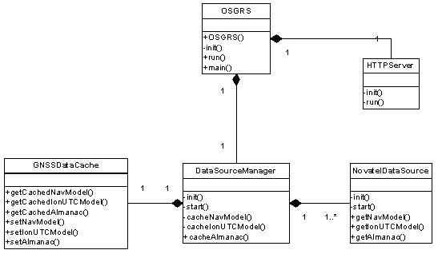
- OSGRS.DataSourceManager
This class co-ordinates the activities of the data receivers, it retrieves assistance data receivers from the data source classes and then passes the assistance data onto the GNSSDataCache class for caching. It also creates the Data Cache. It is compatible with any data source that implements the DataSource interface.
- NovatelDataSource
The main purpose of this class is to retrieve assistance data from a NovAtel reference receiver and deliver it to the DataSourceManager upon request. It will also force caching of certain data types when new data is received.
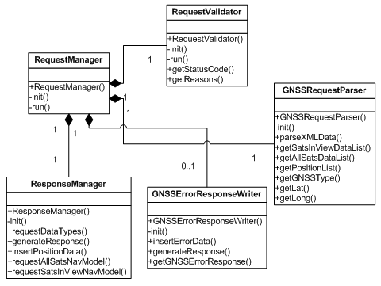
- XMLProcessing.RequestManager
This class co-ordinates the processing of requests. An instance of this class is needed for each request
- XMLProcessing.RequestValidator
This class validates the XML request against the XML Schema. It reports any errors found in the request. The Xerces XML parser is used for the validation.
- XMLProcessing.ErrorResponseWriter
This class is used to create GNSSErrorResponse XML documents.
- XMLProcessing.GNSSRequestParser
This class parses the XML Request.
- XMLProcessing.ResponseManager
Retrieves requests data from data cache and generates a GNSSResponse.

- Pluggable architecture class diagram
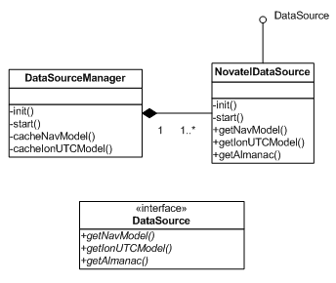

- OSGRS.DataSource
This interface class will be implemented by all data source classes, it defines the pluggable architecture of data sources.
- Interfaces
- Component interfaces
The OSGRS component will run as a standalone package.
- Application level Testing
The OSGRS will have its own test harness.
- User support
- Environment
All classes will be delivered as a single jar file. In the design environment the class files are used directly from the classes directory created by the build.
- Operation
to run this component... TBD
- Debug
Debug outputs are controlled using the Logger class in the java.util.logging component. The different levels of debugging supported are:
- OFF
No output.
- SEVERE
The highest value; intended for extremely important messages (e.g. fatal program errors)
- INFO
Informational runtime messages
- FINEST
Used for greater detail, when debugging/diagnosing problems, to put the OSGRS into this mode, “debug=1” needs to be passed as an argument.
- Configuration
- Configuration items
The OSGRS component defines the configuration items as described in OSGRS Configuration Items”.
- OSGRS Configuration Items
Section |  |  |  | Description
 | Name | Type | Valid Range | Description
Staleness Timer
 | globalDataTimeOutIntervalMinutes | int | 1..2880  Default: 120 | The number of minutes before assistance data is marked as stale and removed from the data cache.
 | almanacDataTimeOutIntervalDays | int | 0..2  Default: 1 | The number of days before almanac data becomes stale and is removed.
 | TOWAssistDataTimeOutIntervalSeconds | int | 0..500  Default: 250 | The number of seconds before TOW assist data becomes stale and is removed.
Ouput verbosity
 | ouputVerbosity | int | 0..3  Default: 1 | This is the output verbosity, 0=no output 1=severe , 2=runtime information, 3=finer details, debugging and diagnosing problems
Data Source locale
 | GNSSDataSource | String | -- | The assitance data source, this is the name of the class that retrieves data.
Current Version
 | gripVersion | String | -- | This is the version of the GRIP protocol
Listener Port
 | listenerPort | int | 0..65535  Default: 80 | This is the port number that the OSGRS will listen for connections on.

- Detailed design
- Assumptions
- Operating Environment
OSGRS has been developed and tested on the Microsoft Windows XP platform using J2SE 5.0 and version 6.1.1 of the Jetty Web Server. The behaviour has only been tested and verified using these versions in the operating environment.
- Equipment
The OSGRS has been designed to communicate with the NovAtel receivers via a terminal server over IP. The classes in the NovAtel package will need to be modified if another method of connection with the receivers is to be implemented e.g. direct serial connection.
- Client Requests
Client requests must be in the form of an HTTP 1.1 POST method. details of POST request can be found in the GRIP document
The xml request in the body of the POST method should follow the GRIP 1.5 XSD files. Xml validation uses the Xerces sax xml parser to validate the xml request. Any errors found in the request whilst validating against the request XSD are sent back to the user via the ‘GNSSErrorResponse’
At this stage all errors reported by the validation process result in a error response being sent to the client. It may be desirable to pass through certain errors, such as incorrect capitalization
- Receiver
The output of the receiver is assumed to be valid and working correctly.

- Component Behaviour
- Handling Requests
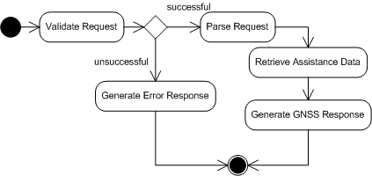
All requests must be validated. If they fail Validation, an error Response is sent to the client. If validation is passed, the XML request is parsed and required assistance data is retrieved. This data is used to create a GNSSResponse which is sent to the client.
- Generating SIV
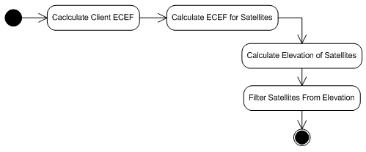
When generating the satellites in view, the client’s position in ECEF is first calculated using the supplied latitude and longitude. The ECEF’s of all the satellites are then calculated. The elevation of each of the satellite is then calculated with respect to the client’s position. The satellites are then selected based on whether their elevations are above the cut-off angle.

- Adding data to Cache
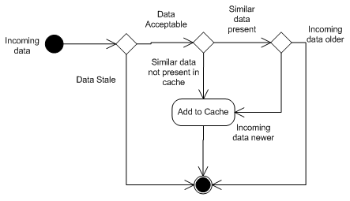
Data that is to be added to the cache must first pass the staleness test. If data has failed this test, data will not be added to the cache. If data has passed this test, a check should be made as to whether this data already exists in the cache. If it doesn’t exist, this data will be added. If it does exist, it will be added if the incoming data is newer than the existing data.
- Object Interactions
- Xml request Processing and response generation
- HTTP Server
This class sets up an instance of the Jetty web container upon creation. The type of connector used for the listener port is a socket connector. This connector uses blocking IO and synchronous threading model.
The main servlet is responsible for co-ordinating the activities associated with processing requests and sending responses. This class strips the xml request from the POST request body and sends it to the request manager for processing. After a response is generated, it is then sent to the client.
- Request Manager
The request manager takes the xml request as a string and uses it generate a response using the ‘ResponseManager’ class. The string is first passed to the ‘RequestValidator’. If validation is successful, the assistance types requested are determined using ‘GNSSRequestParser’.
The assistance types are in two groups; ‘All sats data’ and ‘Sats in View data’. The ResponseManager is used to generate the response based on which data types are requested. As each data type has its associated function call in the ResponseManager, this class makes the appropriate calls depending on the requested data types. A GNSSResponse is then generated and is ready to be sent to the client.
If validation is unsuccessful, an ‘error response’ is generated by passing the error messages provided by the RequestValidator to the GNSSErrorResponseWriter class. It is this response that will be sent to the client instead of a GNSSResponse.
- Request Validator
The RequestValidator uses to the Xerces SAX parser to perform validation of the xml request against the schema file GNSSRequest.xsd. A string array and index variable are used to hold any error messages thrown in the validation. An int variable named ‘status_code’ is used to indicate whether the validation was successful or whether errors were encountered
This class accepts the xml request as a string. It then creates an xml file from this request. If any errors were encountered in this process, the statusCode variable is set to indicate failure and messages from exceptions thrown are added to the string array.
If the creation of the xml file was successful, it will now be validated against the request schema file. An XMLReader object is used to do the validation. The validation feature is set in the init() method for the RequestValidator. A handler is registered with the XMLReader object to handle any errors found in the validation process. When the ‘parse’ method is called on the XMLReader object, validation will take place. This method is sequential. If an error is encountered, the handler will add the message from the exception to the string array and set the statusCode variable to indicate failure.
If no errors were found, the string array will be empty and statusCode variable should indicate success. The request manager will should use the statusCode variable to determine what type of response should be generated.
- Response Manager
The response manager is responsible for the generation of the GNSSResponse. It uses the GNSSResponseWriter class to create the response. Depending on the methods called by the Request manager, this class will insert the appropriate data into the GNSS response.
The assistance data is taken from the GNSSDataCache. If satellites in view data is requested, a SatellitesInView is created using the SIV Generator.
After all the assistance data has been inserted, the response is generated by calling the generateResponse() function and the response is ready to be sent to the client.

